Alexander Baldree
2/18/26
Module 8.1 Discussion Board
CSD340

#65 Doing Things Together Bonds People Together
This concept explains that shared experiences create stronger emotional connections between people. When individuals participate in something together; whether that’s solving a problem, playing a game, or contributing to a discussion; they feel more connected. From a design perspective, this is powerful. Websites that encourage collaboration, interaction, or shared progress naturally create loyalty and community.
Embellishment:
What the book does not deeply explore is the neuroscience behind this bonding. Research on mirror neurons shows that when people observe or participate in shared activity, similar brain regions activate across participants. This neurological alignment increases empathy and trust. That is why collaborative tools like shared dashboards, comment sections, and multiplayer experiences feel engaging; they trigger psychological synchronization. In web design, even small, shared experiences such as live reaction counts, collaborative playlists, or shared progress bars can strengthen connection because users feel like they are part of something bigger than themselves.
Visual Example:
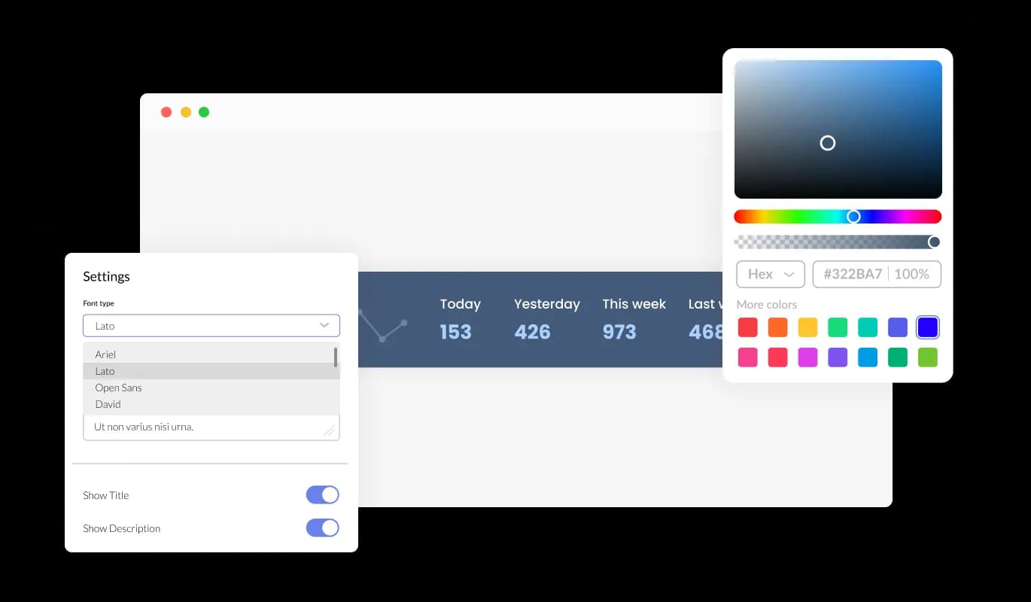

This interface shows shared dashboards, forums, and progress indicators that visually reinforce collective participation. When users see others contributing to real time, the design itself strengthens the sense of community.

#67 People Lie to Differing Degrees Depending on the Medium
This section explains that the likelihood of deception increases depending on how removed a communication medium is from face-to-face interaction. People are generally more honest in person and more likely to distort truth in text-based or anonymous formats.
Embellishment:
One deeper implication for designers is how interface design can either encourage accountability or enable dishonesty. Research in communication studies shows that anonymity lowers perceived consequences, which increases deceptive behavior. Design decisions such as verified badges, profile photos, activity history, and transparent moderation policies reduce lying because they increase identity visibility. On the other hand, completely anonymous comment sections often experience more trolling or misinformation. The medium shapes behavior.
Visual Example:


This example illustrates how visible identity markers and accountability systems influence honesty online. Verified profiles and structured moderation visually communicate credibility, while anonymous systems often lack those trust cues.

References:
100 Things Every Designer Needs To Know About People Susan M. Weinschenk Ph.D.
Topic 65: Doing things together bonds people together Pg.149-150
Topic 67: People lie to differing degrees depending on the medium Pg.153-155

